# WEEK – 1:

**Aim**: Design the following static web pages required for online book store.

1. **Home page:-** the static home page must contains three pages
2. **Top frame:-** logo and college name and links to homepage, login page, registration Page, catalogue page and cart page
3. **Left frame:-** at least four links for navigation which will display the catalogue of Respective links
4. **Right frame:-** the pages to links in the left frame must be loaded here initially it Contains the description of the website

## SOURCE CODE:-

<frameset rows="18%,*">

<frame src="topframe.html" scrolling="no"/>

<frameset cols="15%,*">

<frame src="leftframe.html" noresize/>

<frame src="rightframe.html" name="rframe"/>

</frameset>

</frameset>

<html>

<head>

<title> Top Frame </title>

</head>

<body bgcolor=#bbffbb>

<table border="1" width="100%">

**bookstore.html**

**topframe.html**

<tr> <th width="14%"> <img src="book.gif" width=100 height=50/></th>

<th> AMAZON.COM </th>

</tr>

</table>

<table border="1" width="100%">

<tr>

<th><a href="rightframe.html" target="rframe">Home</a></th>

<th><a href="login.html" target="rframe">Login</a></th>

<th><a href="register.html" target="rframe">Register</a></th>

<th><a href="catalogue.html" target="rframe">Catalogue</a></th>

<th><a href="cart.html" target="rframe">Cart</a></th>

</tr>

</table>

</body> </html>

<html>

<head>

<title> Left Frame </title>

</head>

<body bgcolor=#ffffcc>

<center>

**leftframe.html**

<h4><a href="cse.html" target="rframe">CSE</a> </h4>

<h4><a href="ece.html" target="rframe">ECE</a> </h4>

<h4><a href="eee.html" target="rframe">EEE</a> </h4>

<h4><a href="it.html" target="rframe">IT</a> </h4>

</center></body> </html>

<html>

<head>

<title> Right Frame </title>

</head>

<body bgcolor="pink">

</body> </html>

<html>

<head>

<title> Login </title>

</head>

<body bgcolor="pink">

<center>

<form> &nbsp;&nbsp;&nbsp;&nbsp;

**rightframe.html**

**login.html**

<b>Login: <input type="text" name="login"/> <br><br>

Password: <input type="password" name="password"/> <br><br>

<input type="submit" value="Submit"/>

<input type="reset" value="Reset"/>

</b>

</form>

</center>

</body> </html>

<html>

<head></head>

<title> Catalogue </title>

<body bgcolor="pink">

<form>

<table border="1" width="100%">

<tr>

**catalogue.html**

<td> <img src="sunset.jpg" width=100 height=100/></td>

<td> Book: XMLBIBLE <br> Author: Winston <br> Publication:wiley</td>

<td> $40.5 &nbsp;&nbsp;&nbsp;</td>

<td> <input type="button" value="Add to cart"/></td>

</tr>

<tr>

<td> <img src="ns.jpg" width=100 height=100/></td>

<td> Book: AI <br> Author: S.Russel <br> Publication:PrincetonHall</td>

<td> $63 &nbsp;&nbsp;&nbsp;</td>

<td> <input type="button" value="Add to cart"/></td>

</tr>

</table>

</form> </body> </html>

**Result:-**

**HOME PAGE**

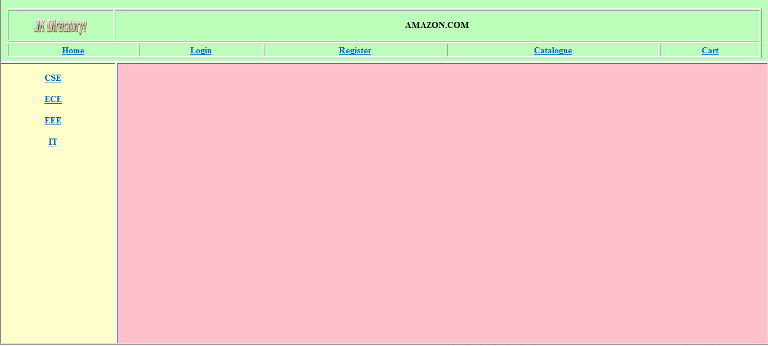

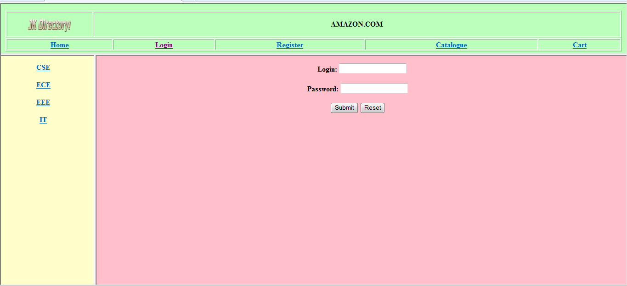**LOGIN PAGE**

**CATALOGUE PAGE**

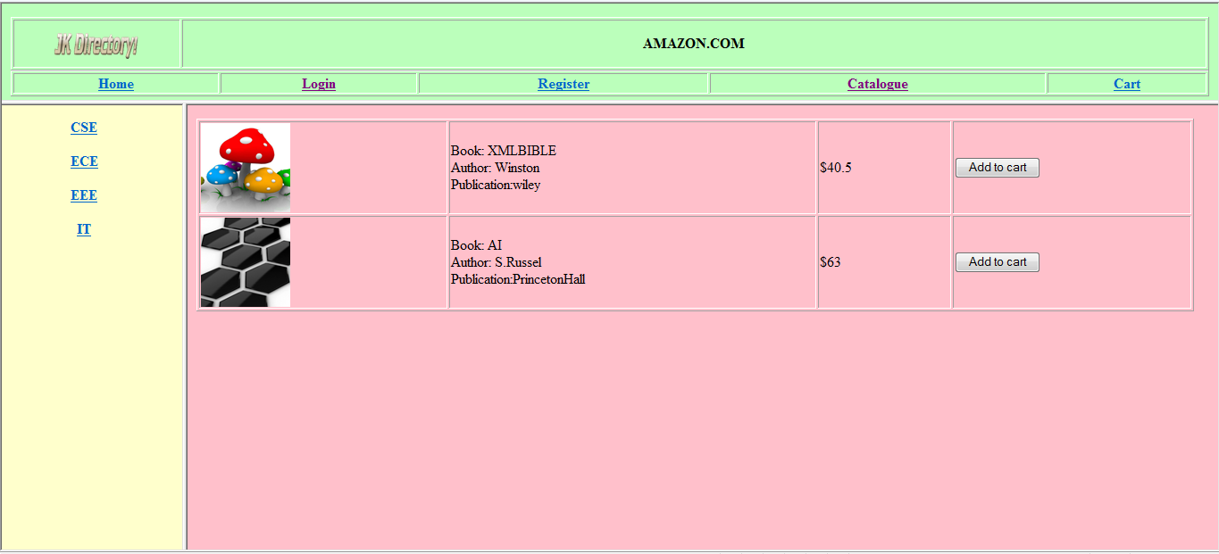

# WEEK – 2:

**Aim**: Design the following static web pages required for online book store.

1. **Home page: -** the static home page must contains three pages
2. **Top frame: -** logo and college name and links to homepage, login page, registration Page, catalogue page and cart page
3. **Left frame: -** at least four links for navigation which will display the catalogue of Respective links
4. **Right frame: -** the pages to links in the left frame must be loaded here initially it Contains the description of the website
5. **Registration page** and
6. **Cart page**

## SOURCE CODE:-

<frameset rows="18%,*">

<frame src="topframe.html" scrolling="no"/>

<frameset cols="15%,*">

<frame src="leftframe.html" noresize/>

<frame src="rightframe.html" name="rframe"/>

</frameset>

</frameset>

<html>

<head>

<title> Top Frame </title>

**bookstore.html**

**topframe.html**

</head>

<body bgcolor=#bbffbb>

<table border="1" width="100%">

<tr> <th width="14%"> <img src="book.gif" width=100 height=50/></th>

<th> AMAZON.COM </th>

</tr>

</table>

<table border="1" width="100%">

<tr>

<th><a href="rightframe.html" target="rframe">Home</a></th>

<th><a href="login.html" target="rframe">Login</a></th>

<th><a href="register.html" target="rframe">Register</a></th>

<th><a href="catalogue.html" target="rframe">Catalogue</a></th>

<th><a href="cart.html" target="rframe">Cart</a></th>

</tr>

</table>

</body> </html>

**leftframe.html**

<html>

<head>

<title> Left Frame </title>

</head>

<body bgcolor=#ffffcc>

<center>

<h4><a href="cse.html" target="rframe">CSE</a> </h4>

<h4><a href="ece.html" target="rframe">ECE</a> </h4>

<h4><a href="eee.html" target="rframe">EEE</a> </h4>

<h4><a href="it.html" target="rframe">IT</a> </h4>

</center></body> </html>

<html>

<head>

<title> Right Frame </title>

</head>

<body bgcolor="pink">

</body> </html>

**rightframe.html**

**cart.html**

<html>

<head> </head>

<title> Cart page</title>

<body>

<center>

<table width="100%">

<tr>

<th>Book Name </th>

<th>Price </th>

<th>Quantity </th>

<th>Amount </th>

</tr>

<tr>

<td align="center">XML Bible </td>

<td align="center">$40.5 </td>

<td align="center">01 </td>

<td align="center">$40.5 </td>

</tr>

<tr>

<td align="center">JAVA </td>

<td align="center">$35.5 </td>

<td align="center">02 </td>

<td align="center">$70 </td>

</tr>

<tr>

<td> </td> <td> </td><th>Total Amount</th>

<td align="center">$110.5</td>

</tr>

</table> </center>

</body> </html>

<html>

<head> </head>

<title> New User! </title>

<body>

<form>

<center>

**register.html**

<h1> <font size="3"> Registration Form </font> </h1>

<hr witdh="50%">

<pre>

User Name: <input type="text" maxlength=15 size=25/> Password: <input type="password" maxlength=15 size=25/>

Confirm Password: <input type="password" maxlength=15 size=25/>

Gender: <input type="radio" name="a">Male</input><input type="radio" name="a">Female</input> Email-ID: <input type="text" maxlength=15 size=25/>

Address: <textarea rows=5 cols=30> </textarea>

<input type="submit" value="Submit"/><input type="reset" value="Reset"/>

</pre> </form> </body> </html>

**Result:-**

**HOME PAGE**

**CART PAGE**

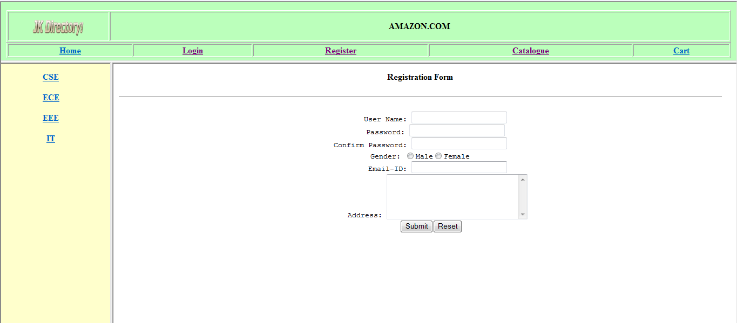

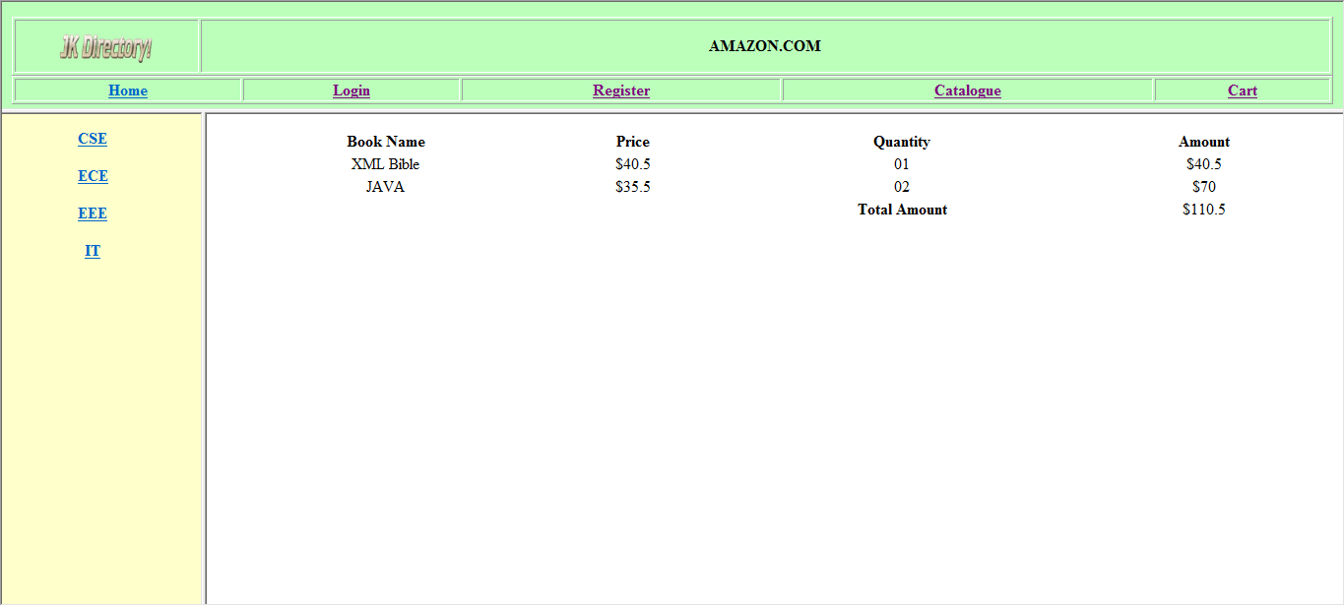REGISTRATION PAGE

**WEEK – 3:**

**Aim**: Write a java script to validate the following fields in a registration page

1. Name (should contains alphabets and the length should not be less than 6 characters)
2. Password(should not be less than 6 characters)
3. E-mail(should not contain invalid addresses)

## SOURCE CODE:-

**validate.html**

<html>

<head> <h1 align=center>Welcome to Validation Checking</h1><hr width=50%>

<script language="javascript"> function validation()

{

var x=f.un.value; var len=x.length; var val=x.charCodeAt(0); var p=f.pw.value; var c=f.cpw.value;

var a=f.email.value; var atpos=a.indexOf("@"); var dotpos=a.lastIndexOf("."); if(len<6 || x=='' || x==null)

{

alert("check your username! must be minimum 6 characters"); if(val<65 || val>90 && val <97 || val>122)

alert("username must begin with an alphabet"); return false;

}

else if(val<65 || val>90 && val <97 || val>122)

{

alert("username must begin with an alphabet"); return false;

}

else if(p=='' || c=='' || p.length<6 || c.length<6 || p!=c)

{

alert("Password and Confirm Password should be same and greater than 6 characters!"); return false;

}

else if(atpos<6 || dotpos<atpos+6 || dotpos+2>=a.length)

{

alert("Not a valid email id"); return false;

}

else

alert("Congragulations! you have submited successfully");

}

</script>

</head>

<title> Validation Check! </title>

<body>

<table align=center border=1>

<form name="f" action="success.html" onsubmit="return validation();" method="post">

<tr><td>User Name:</td><td><input type="text" name="un"/></td></tr>

<tr><td>Password:</td><td><input type="password" name="pw"/></td></tr>

<tr><td>Confirm Password:</td><td><input type="password" name="cpw"/></td></tr>

<tr><td>E-mail ID:</td><td><input type="text" name="email"/></td></tr>

<tr><td></td><td><input type="submit" value="Submit"/></td></tr>

</form></table>

</body>

</html>

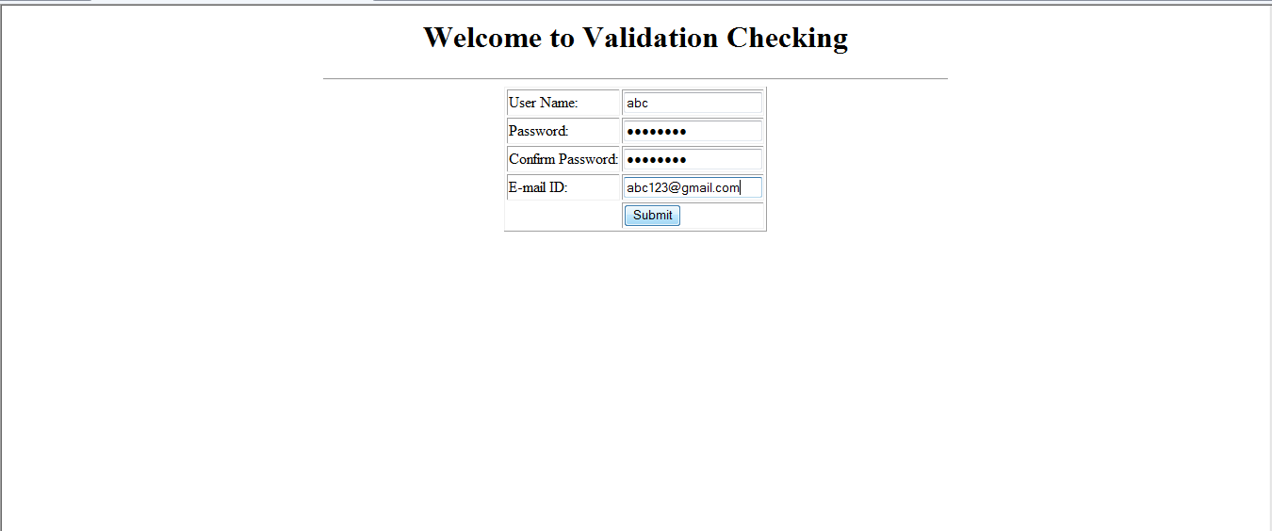**Result:-**

After the details entered and by clicking submit button it show the dialog box as follows:

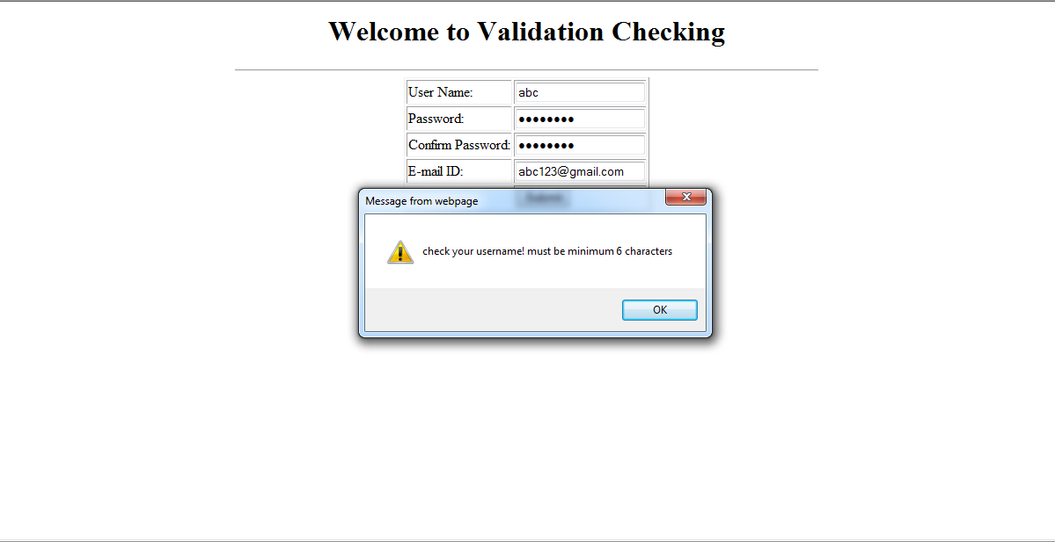

After clicking OK button it is redirected to validate.html

If the username, password, confirm password, and e-mail are entered correctly then it shows the dialog box as follows:

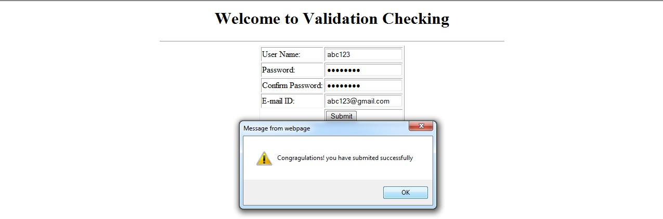

After clicking OK button the page is redirected to success.html

# WEEK – 4:

**Aim**: Design a web page using CSS which includes the following:

1. Use different font styles
2. Set background image for both the page and single elements on page.
3. Control the repetition of image with background-repeat property
4. Define style for links as a:link, a:active, a:hover, a:visited
5. Add customized cursors for links.
6. Work with layers.

## SOURCE CODE:-

**css.html**

<html>

<head> <h1 align=center> Web Page using CSS </h1>

<style type="text/css">

body{background-image:url(img2.jpg); background-repeat:repeat-y;} p{color:yellow ;font-size:20pt;font-family:chiller;background-image:url(img1.jpg);} a:hover{font-size:20pt;background-color:yellow;cursor:crosshair;}

a:link{font-size:20pt;background-color:white;}

a:active{font-size:20pt;background-color:cyan;cursor:help;} a:visited{font-size:20pt;background-color:tan;}

</style>

</head>

<title> CSS Webpage!!! </title>

<body>

<br>

<p> Weclome to Web page using CSS where CSS means Cascading Style Sheets! using CSS we can apply the common styles to different tags and also different

styles to same tag i.e. repeated more than once in the html file </p>

<a href="sample1.html"><center> Register </center.</a>

<br><br><br><br><br><br><br><br><br>

<center><div style="position:relative;font-size:50px;z-index:2;">LAYER 1</div>

<div style="position:relative;top:-50;left:5;color:red;font-size:80px;z-index:1;">LAYER 2</div>

<div style="position:relative;font-size:50px;z-index:3;">LAYER 1</div>

<div style="position:relative;top:-50;left:5;color:red;font-size:80px;z-index:4;">LAYER 2</div>

</center>

</body>

</html>

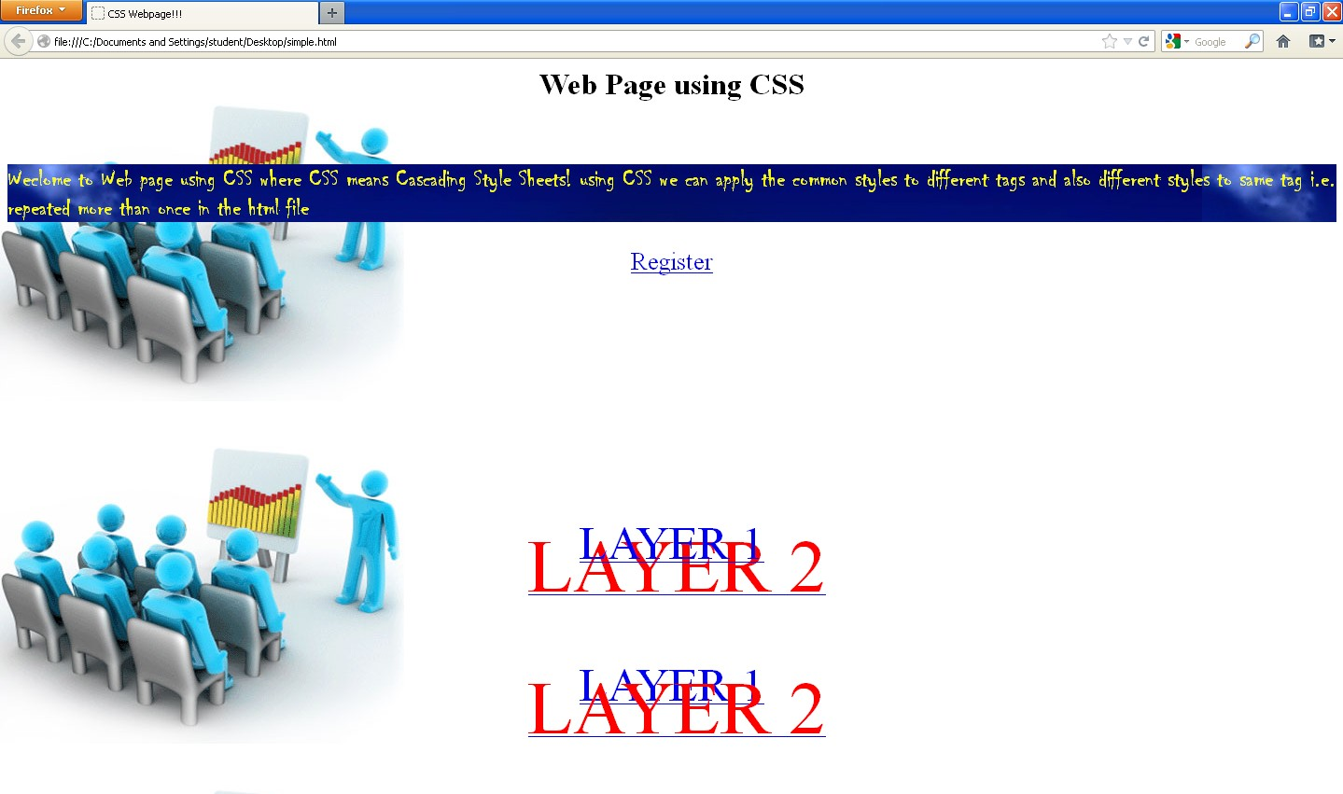**WEB PAGE USING CSS**